Experiment 3

Designing a Quarter Wave Transformer by Varying Frequency, Input Impedance and Characteristic Impedance
Test Case 1
Design a quarter-wave transformer for an input impedance (Zin) of 50 Ω and a load impedance (ZL) of 100 Ω. Analyze the transformer's performance as the operating frequency is varied across {100 MHz, 200 MHz, 300 MHz, 500 MHz}.
Code -
clear; clc;
Zr=100; Zs=50;
Ro=sqrt(Zs*Zr);
f=[100 200 300 500]*10^6;
for i=1:4
lambda=300/(f(i)*10^-6); // wavelength in metres
L=lambda/4; // quarter-wave length
printf('f=%d MHz Ro=%f ohm L(lambda/4)=%f m\n',f(i)*10^-6,Ro,L);
end

Output:
ZR = 100 Ω, Zin = 50 Ω → Ro = 70.71 Ω (constant, independent of frequency)
Frequency (MHz) | Wavelength λ - Sim (m) | Length of λ/4 transformer - Theory (m)
100 | 3.00 | 0.75
200 | 1.50 | 0.375
300 | 1.00 | 0.25
500 | 0.60 | 0.15

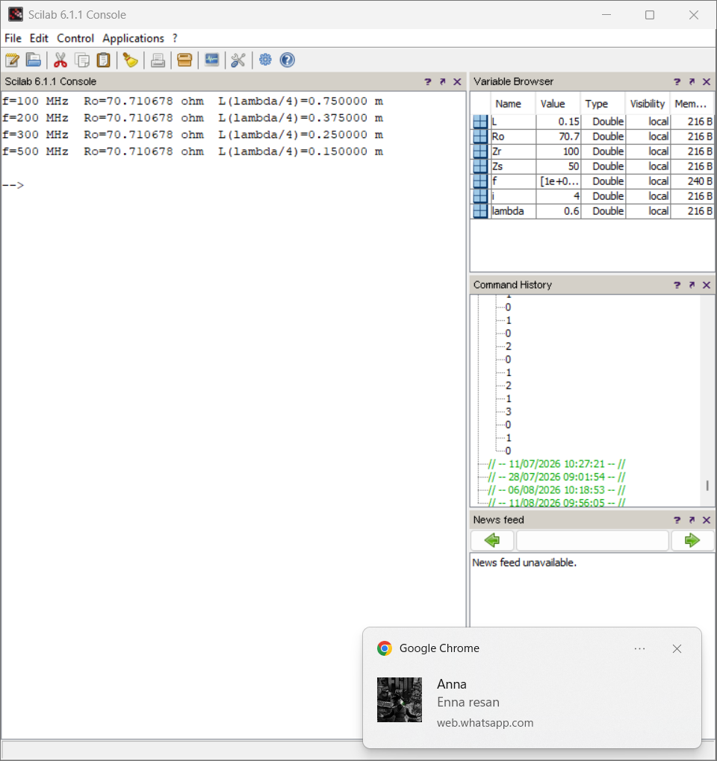
Test Case 2
For a fixed operating frequency of 2 GHz and a load impedance (ZL) of 100 Ω, design a quarter-wave transformer and evaluate its performance as the input impedance (Zin) varies through {25, 50, 75, 100} Ω. Validate that Ro = √(Zin·ZL) changes with Zin.
Code -
clear; clc;
ZL=100; f=2*10^9;
Zin=[25 50 75 100];
for i=1:4
Ro=sqrt(Zin(i)*ZL);
printf('Zin=%d ohm Ro=%f ohm\n',Zin(i),Ro);
end
Output:
ZL = 100 Ω, f = 2 GHz → Variable: Zin
Zin (Ω) | Ro (ohms) - Simulation | Ro (ohms) - Theoretical
25 | 50.00 | 50.00
50 | 70.71 | 70.71
75 | 86.60 | 86.60
100 | 100.00 | 100.00

